* Inside the nav tag, there is a div and a ul list. The div has a <A> tag which contains the name of the company.
* The ul tag contains two <A> tags in which one of the tags points to the plans section on the same page while the other links to the subscription page.

* The nav bar is a flex item. Using flex property, the Company name and list that has plans and subscription links can be horizontally aligned.
* Justify-content property all the available space is inserted between logo div and nav__list.
* Nav bar is also applied with top left right and bottom padding.
* The nav list(<UL> tag) is also a flex item. This is to align the plans and subscription text(<A> tag  
  horizontally. Using flex property for the nav bar won’t make both div and ul horizontally aligned because the list items will be one below one. To solve this, we use flex property for the <UL>A screenshot of a computer

  Description automatically generated with medium confidence

* The background of the nav bar is changed to a custom color. Also, the font size is set to 1.5*(root font size). Here for the smaller devices, we changed the (html tag) font size to 10px and for large devices back to default 16px.
* When the width of a device is above 600px the padding of the nav bar is changed slightly.

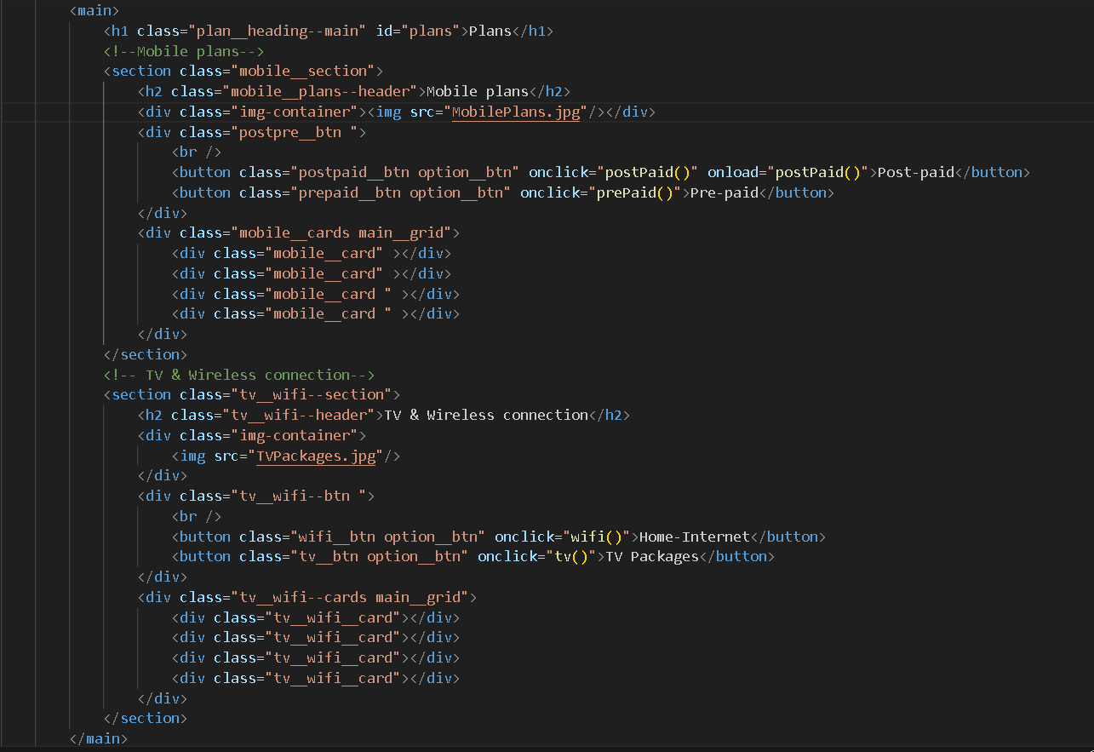

* Under the main tag We have a header for plans
* After that a section of Post-paid and pre-paid plans and below that comes the section of TV and wireless connections